Lab 8
- Leaky bucket
#include <stdio.h>

int min(int x, int y) {
return (x < y) ? x : y;
}

int main() {
int cap, process, nsec;
int inp[25];
int count = 0, drop = 0, mini;

printf("Enter the bucket size:\n");
scanf("%d", &cap);

printf("Enter the processing rate:\n");
scanf("%d", &process);

printf("Enter the number of seconds you want to simulate:\n");
scanf("%d", &nsec);

for(int i = 0; i < nsec; i++) {
printf("Enter the size of the packet entering at %d sec:\n", i+1);
scanf("%d", &inp[i]);
}

printf("\nSecond | Packet Recvd | Packet Sent | Packet Left | Dropped\n");
printf("---------------------------------------------------------------\n");

// Main simulation for given seconds
for(int i = 0; i < nsec; i++) {
count += inp[i]; // packets received

if(count > cap) {
drop = count - cap;
count = cap;
}

mini = min(count, process); // process packets
count -= mini;

printf("%6d | %12d | %11d | %11d | %7d\n", i+1, inp[i], mini, count, drop);
drop = 0;
}

// Flush the remaining packets after time ends
int i = nsec;
while(count > 0) {
if(count > cap) {
drop = count - cap;
count = cap;
}

mini = min(count, process);
count -= mini;

printf("%6d | %12d | %11d | %11d | %7d\n", i+1, 0, mini, count, drop);
drop = 0;
i++;
}

return 0;
}

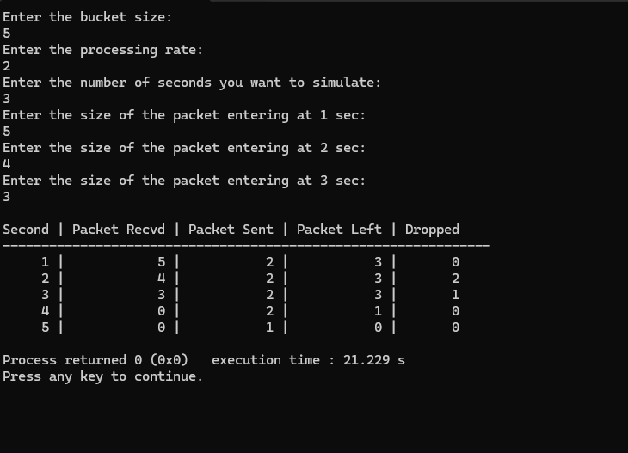

- Crc
#include <stdio.h>
#include <string.h>
#include <stdlib.h>

int main() {
char rem[50], a[80], s[80], c, msj[50], gen[30];
int i, genlen, t, j, flag = 0, k, n;

printf("Enter the generator polynomial (example: 10001000000100001 for CRC-CCITT):\n");
gets(gen);

printf("Generator polynomial is CRC-CCITT: %s\n", gen);

genlen = strlen(gen);
k = genlen - 1;

printf("Enter the message:\n");
n = 0;
while ((c = getchar()) != '\n' && c != EOF) {
msj[n++] = c;
}
msj[n] = '\0';

// Copy message and append k zeros
for (i = 0; i < n; i++)
a[i] = msj[i];
for (i = 0; i < k; i++)
a[n + i] = '0';
a[n + k] = '\0';

printf("\nMessage polynomial appended with zeros:\n");
puts(a);

// Division to get remainder
for (i = 0; i < n; i++) {
if (a[i] == '1') {
t = i;
for (j = 0; j <= k; j++) {
a[t] = (a[t] == gen[j]) ? '0' : '1';
t++;
}
}
}

// Extract remainder
for (i = 0; i < k; i++)
rem[i] = a[n + i];
rem[k] = '\0';

printf("The checksum (remainder) is:\n");
puts(rem);

printf("\nMessage with checksum appended:\n");
for (i = 0; i < n; i++)
a[i] = msj[i];
for (i = 0; i < k; i++)
a[n + i] = rem[i];
a[n + k] = '\0';
puts(a);

// Receiver side
printf("\nEnter the received message:\n");
n = 0;
while ((c = getchar()) != '\n' && c != EOF) {
s[n++] = c;
}
s[n] = '\0';

// Re-division at receiver
for (i = 0; i < n; i++) {
if (s[i] == '1') {
t = i;
for (j = 0; j <= k; j++, t++) {
s[t] = (s[t] == gen[j]) ? '0' : '1';
}
}
}

// Check remainder at receiver
for (i = 0; i < k; i++)
rem[i] = s[n + i];
rem[k] = '\0';

for (i = 0; i < k; i++) {
if (rem[i] == '1')
flag = 1;
}

if (flag == 0)
printf("Received polynomial is ERROR-FREE\n");
else
printf("Received polynomial contains ERROR\n");

return 0;
}
